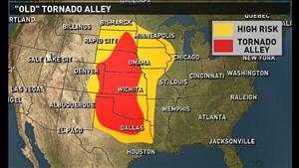 1974 National Tornado Alley

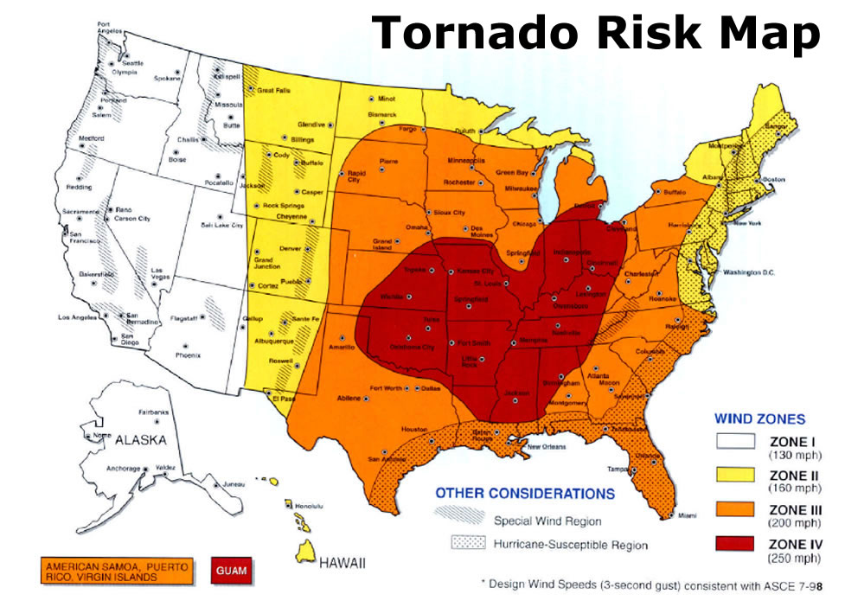 2014 National Tornado Alley

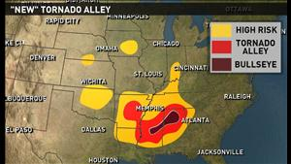 2014 Georgia’s Mini-Tornado Alley

