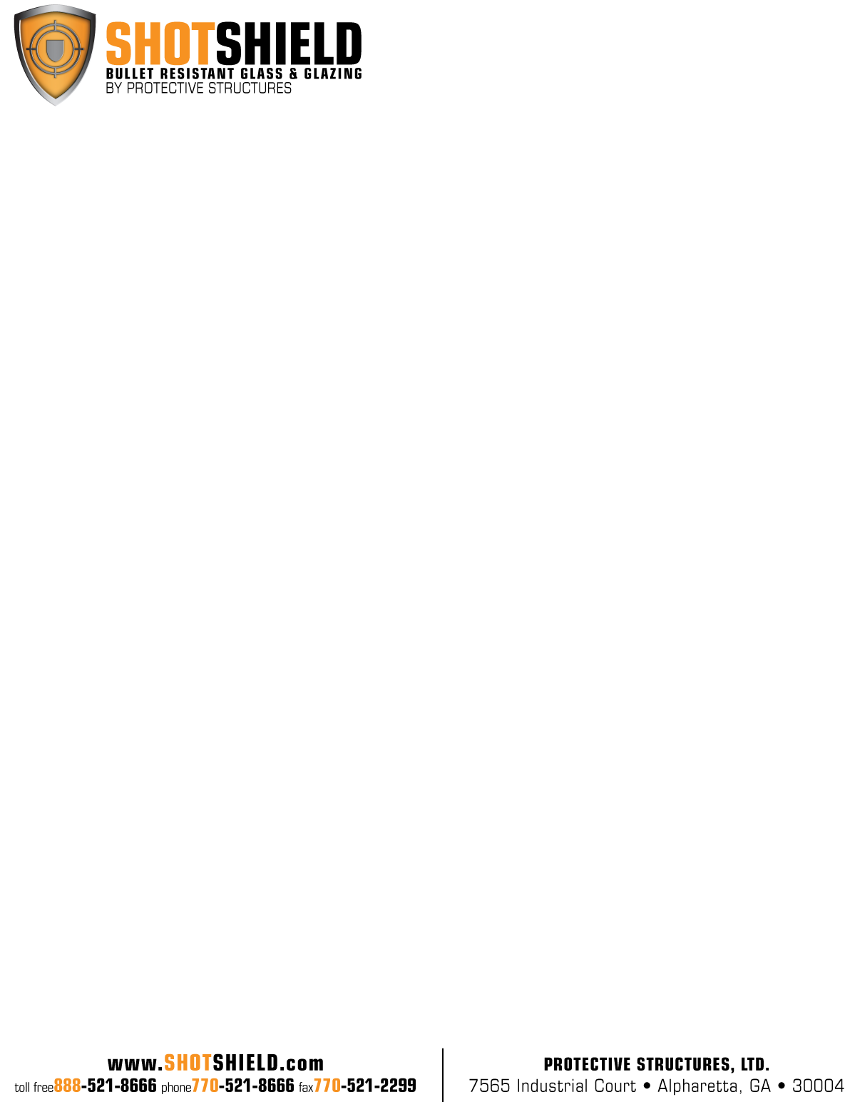

**PRODUCT NAME: UL Level 3 - Lexgard®**

**PRODUCT CODE: SS-P1250**

**PERFORMANCE TESTING:** Ballistic: UL Standard 752 – Level 3

.44 Magnum Lead Semi-Wadcutter Gad Checked

No Spall, No Penetration

**CONSTRUCTION:** 1/8” Polycarbonate (Abrasion Resistant)

Urethane Interlayer

1/2” Polycarbonate

Urethane Interlayer

1/2” Polycarbonate

Urethane Interlayer

1/8” Polycarbonate (Abrasion Resistant)

**THICKNESS:** 1-1/4” Nominal (1.25”)

**THICKNESS TOLERANCE:** .1.17” / 1.45”

**WEIGHT:**  7.70 Lbs. / Square Foot

**SIZE:** 72” x 96” Maximum

12” x 12” Minimum

**OPTIONS:** Bronze, gray, green tint

**TECHNICAL DATA:** U-Value- .56

Shading Co-efficient- .90

Light Transmission- .67

**INSTALLATION:** Glass must be installed in a UL Level 3 Bullet Resistant frame system. Holes must be covered with a UL listed device. All glass should be installed in accordance with the guidelines set forth in the current edition of the Glass Association of North America (GANA) Glazing and Sealant Manuals. Glazing systems should incorporate a weep system to allow moisture and water to escape the glazing channel.

Recommended Clearance:

Face: 1/8” per side

letterhead curvesEdge: 1/4”

Bite: 1”

Lexgard® products combine polycarbonate with polyurethane interlayers to achieve various levels of ballistic threat and extensive attack resistance. Exposed polycarbonate surfaces are abrasion resistant for maintenance.