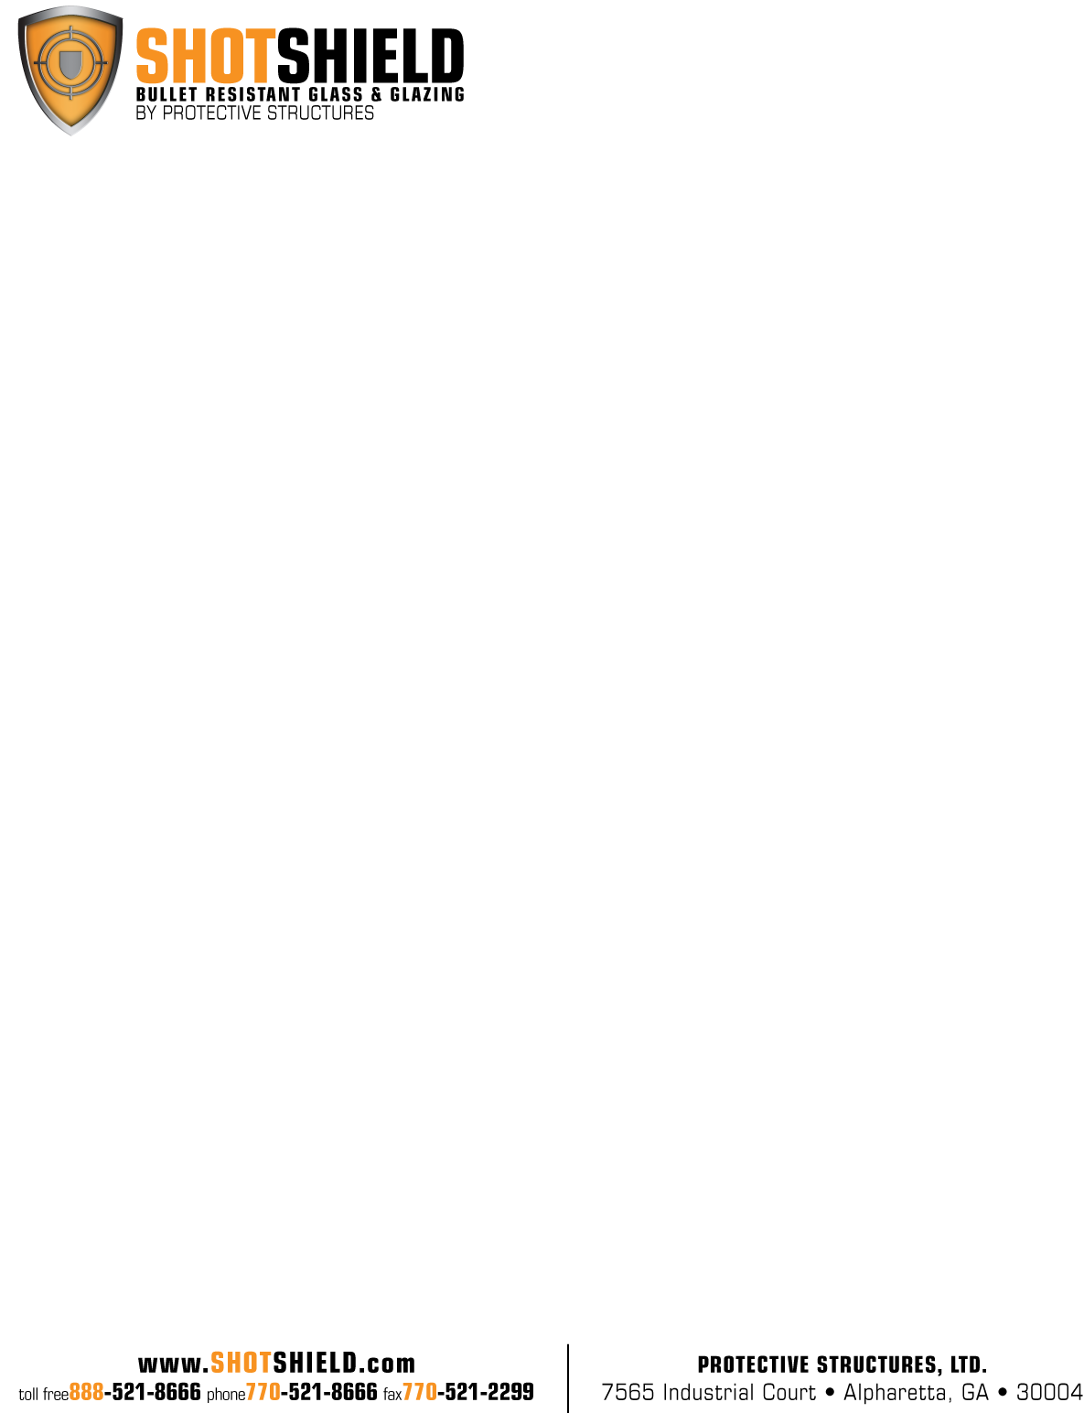

**PRODUCT NAME: UL Level 4 – Laminated Glass**

**PRODUCT CODE: SS-LG4000**

**PERFORMANCE TESTING:** Ballistic: UL Standard 752 – Level 4

.30 Caliber Rifle Lead Core Soft Point (.30-06 Caliber)

No Spall, No Penetration

**CONSTRUCTION:** Product Construction is Proprietary

**THICKNESS:** 2-1/8”Normal (2.125”)

**THICKNESS TOLERANCE:** 1.996”/2.245”

**WEIGHT:** 25.66 Lbs. / Square Foot

**SIZE:** 60” x 96” Maximum

12” x 12” Minimum

**OPTIONS:** Tinted Glass, Translucent Layers, Transparent Mirror, Low iron Glass

**TECHNICAL DATA:** U-Value- .81

Shading Co-efficient- .68

Light Transmission- .71

**APPLICABLE STANDARDS:** ANSI Z97.1

CPSC 16 CRF 1201 (Category I and II)

ASTM C 1036

ASTM C 1172

**INSTALLATION:** Glass must be installed in a UL Level 4 Bullet Resistant frame system. Holes must be covered with a UL listed device. All glass should be installed in accordance with the guidelines set forth in the current edition of the Glass Association of North America (GANA) Glazing and Sealant Manuals. Glazing systems should incorporate a weep system to allow moisture and water to escape the glazing channel.

Recommended Clearance:

Face: 1/8” per side

letterhead curvesEdge: 13/8”

Bite: 1”