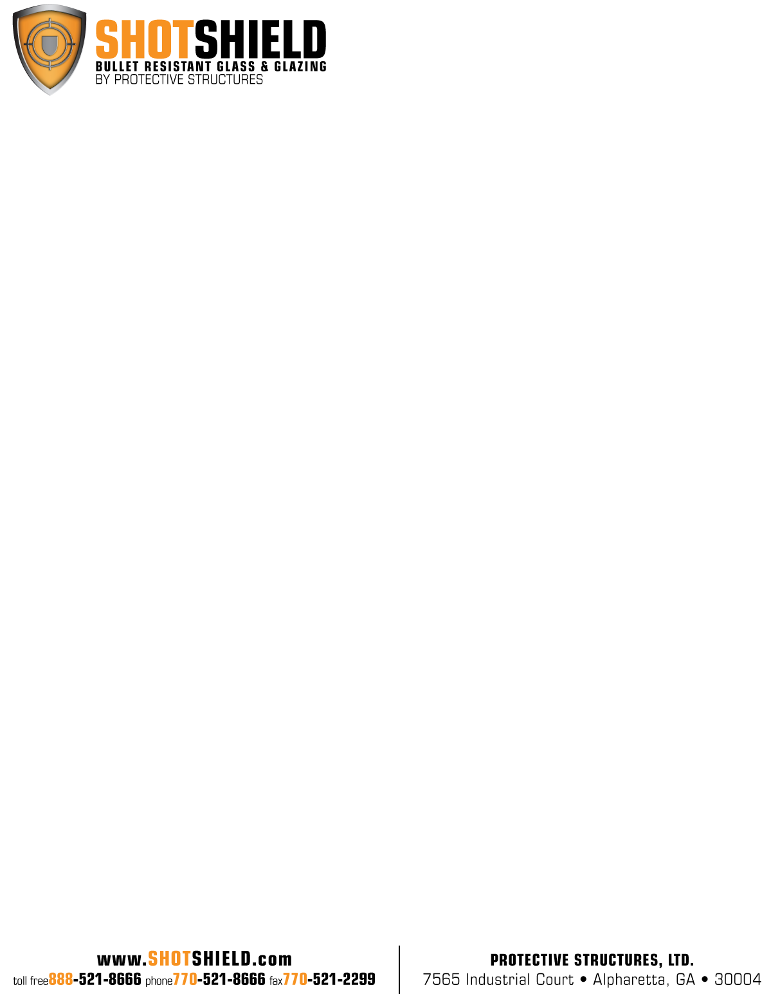

**PRODUCT NAME: UL Level 8- Secur-Tem + Poly®**

**PRODUCT CODE: SS-XT8800**

**PERFORMANCE TESTING:** Ballistic: UL Standard 752 – Level 8

7.62mm Rifle Lead Core Full Metal Copper Jacket

Military Ball (.308 Caliber) One (5) Shot

No Spall, No Penetration

**CONSTRUCTION:** Product construction is proprietary. This product is glass-clad polycarbonate and contains an exposed polycarbonate surface with an abrasion resistant coating on the witness (safe) side.

**THICKNESS:** 2” Nominal (2.00”)

**THICKNESS TOLERANCE:** 1.927” / 2.227”

**WEIGHT:** 21.21 Lbs. / Square Foot

**SIZE:** 60” x 96” Maximum

12” x 12” Minimum

**OPTIONS:** Tinted glass, translucent interlayers, transparent mirror, Low Iron glass

**TECHNICAL DATA:** U-Value- .60

Shading Co-efficient- .66

Light Transmission- .58

**APPLICABLE STANDARDS:** ANSI Z97.1

CPSC 16 CFR 1201 (Category I and II)

ASTM C 1036

ASTM C 1349

**INSTALLATION:** Glass must be installed in a UL Level 8 Bullet Resistant frame system. Holes must be covered with a UL listed device. All glass should be installed in accordance with the guidelines set forth in the current edition of the Glass Association of North America (GANA) Glazing and Sealant Manuals. Glazing systems should incorporate a weep system to allow moisture and water to escape the glazing channel.

Recommended Clearance:

Face: 1/8” per side

Edge: 3/8”

Bite: 1”

Secur-Tem+Poly® products combine the durability and abrasion resistance of glass on the “attack” side and the impaletterhead curvesct resistance of polycarbonate to the “witness” side, providing thinner and lighter products with “no spall” protection.